EBG-10-06

Identification and Development of Integrated Biodiversity Delivery Areas (IBDAs)

Identification and Development of Integrated Biodiversity Delivery Areas (IBDAs)

- Introduction
  - Achieving biodiversity enhancements at a landscape-scale to support the delivery of priority species and habitat targets is a key aim of the ‘Securing Biodiversity’ framework. This paper aims to update the England Biodiversity Group on the progress made in identifying ‘Integrated Biodiversity Delivery Areas’ (IBDAs) where national, regional and local levels of the partnership will work together to achieve landscape-scale enhancements. Specifically, EBG is invited to:
- Note the significant progress made towards selecting a suite of IBDAs in the nine regional workshops
- Endorse the suite of draft IBDAs identified in Table 1 and the process for their continued development, recognising their important contribution to the Securing Biodiversity framework.
- Agree a formal mechanism for resolving which of the candidate IBDAs are taken forward and ensuring that their development proceeds as proposed . We recommend that this function is delegated to the Securing Biodiversity Management Group.
- Communicate and recommend the value of this integrated landscape-scale approach to member organisations and the wider biodiversity partnership. Encourage member organisations to actively seek opportunities to deliver more for biodiversity in these areas.
- Advise on the timing and method of promoting these areas, in particular in the context of the ‘Making Space for Nature’ review of England’s wildlife sites and ecological network chaired by Prof. Sir John Lawton.
- Advise on what emphasis should be placed on IBDAs and their contribution to delivering BAP targets, so as to achieve a balanced programme addressing all strands of the Securing Biodiversity framework.

- Background

  - The Securing Biodiversity framework has the following aims: encourage the adoption of an ecosystem approach; achieve biodiversity enhancements across whole landscapes; enhance recovery of priority species, including by better integrating their needs into habitat-based work; and improve the integration of national, regional and local levels of delivery. Within the framework, the role of the Biodiversity Integration Groups (BIGs) is described and this includes: identifying and carrying out priority projects for delivery, in particular landscape-scale projects; and working closely with regional and local partnerships to agree the most important areas for landscape-scale delivery. In response, the BIGs are working closely with regional and local biodiversity partnerships to identify a suite of demonstration landscape-scale projects in England, called Integrated Biodiversity Delivery Areas (IBDAs).

  - IBDAs represent areas that are a priority for biodiversity delivery, either for their existing biodiversity interest, biodiversity potential or for the lessons that the sector could learn from focussing action in the area. In addition to being areas where significant BAP delivery will occur for habitats and species, IBDAs will provide demonstrations of better practice in biodiversity conservation, which will allow for improved delivery outside of these areas. They are not intended to deliver all our BAP targets; they will, however, allow us to explore how to better integrate species’ needs into habitat-based work, use resources more efficiently, work more successfully in partnership, work effectively between national, regional and local levels and, of course, deliver real biodiversity improvement. In doing so, IBDAs will also support and stimulate landscape-scale working in other areas. Thus, IBDAs are critical for progressing implementation of the framework.

  - Although the revised framework places greater emphasis on landscape scale conservation, it also recognises the continuing need to address policy issues through crosscutting workstreams and meet species objectives through a programme of targeted species recovery work. These delivery mechanisms will continue to receive full support under the revised delivery arrangements.

  - At the December 2009 EBG meeting, a paper was presented by Natural England called ‘Securing Biodiversity: the delivery framework for habitats and species in England – Update Note 1’ (see Appendix 1). This note presented the concept and rationale for IBDAs and outlined the process that the BIGs were using to identify approximately 20 potential IBDAs. This paper was broadly accepted by the EBG, although the group requested that better links were made between the IBDAs and the Regional Delivery Plans. In response to this request, the process for selection was revised to include a series of regional workshops, where national, regional and local teams could work together to identify a common set of priorities and agree a suite of IBDAs across the country.

- Regional IBDA workshops – an update

  - The Biodiversity Integration Leaders have worked with the Regional Biodiversity Coordinators to host workshops (running from 10-30th March) within each region, to identify potential areas for IBDAs. To encourage wide national, regional and local agreement and promote effective partnership working, the workshops have included representatives from BIGs, taxonomic advisory groups, regional biodiversity partnerships and LBAPs. Workshops were well-supported, with an average of 45 attendees.

  - Ahead of the workshops, the BIGs identified their top 20 priority National Character Areas across England for biodiversity maintenance, enhancement and restoration (described in Appendix 2: ‘Securing Biodiversity: the delivery framework for habitats and species in England – Update Note 2’ ). This output was used alongside regional priority areas and local knowledge to identify the most suitable areas for IBDAs. The diversity between regions was recognised and a flexible approach was adopted in IBDA selection. However, to ensure that IBDAs meet the aims of the framework, the following criteria were adopted:

- IBDAs need to be >10,000ha in size, to be true landscape-scale projects, and they must remain deliverable (which will effectively place an upper limit the size)
- They need to demonstrate significant improvements for a range of different habitats and species, with a defined contribution to the 2015 BAP targets.
- They should demonstrate better integration of species needs into habitat-based work
- They should aim to deliver improvements to all priority habitats that occur within the geographical area
- They must demonstrate significant potential for biodiversity improvement outside of existing projects (or where existing projects have potential to be enhanced), so that the IBDA approach is adding value.
- They must be a true partnership project, demonstrating effective partnership working
- They must align with Regional Delivery Plans
- Dynamic ecosystem processes should be considered

  - At the workshops, background on the framework, IBDAs and regional biodiversity prioritisation was presented. In recognition that the IBDAs will require support to get them to successful implementation, the initial number has been limited to 25 - three per region, with the exception of London, which has one. In all the regions, more than three areas broadly fitted the criteria for IBDAs. The aim of the workshops was to refine this to three, using the criteria to identify those areas that would gain the most from being IBDAs and through discussion.

- Workshop Outputs

  - In seven out of the nine regional workshops, three potential IBDAs were identified (one in London), following the criteria and guidelines set out above. In two regions (SE and SW), the three areas could not be resolved at the workshops and so short-lists have been submitted to the regional biodiversity partnership executive groups for a final decision. The potential impact of this on the proposed timetable is considered in Section 5.

  - The workshop approach identified IBDAs that represent regional priorities for delivery and align well with the Regional Delivery Plans. In nearly all cases, they also represent areas that the BIGs have identified as being nationally important for biodiversity delivery. In addition, many of the IBDA areas were selected by several BIGs and cross regional boundaries, presenting opportunities to demonstrate effective inter-BIG and inter-region working.

  - Issues arising:
    - There was strong support for adopting a landscape scale approach to habitat and species conservation and a recognition that further effort would be needed to halt and reverse biodiversity loss. During the workshops a number of common issues were identified where greater clarity was sought. These included:
- The added value that IBDAs would bring.
- Resourcing of the IBDAs. There was concern that IBDAs would divert funding from existing projects or attract all potential funding.
- How the IBDAs align with current agri-environment targeting and with existing and planned regional work, including existing landscape-scale projects.
- A lack of clarity over the criteria used by the BIGs to identify their 20 priority NCAs.

    - In spite of these concerns, there was a positive feeling that IBDAs could facilitate improved national, regional and local linkages and the involvement of national specialists and BIG and Taxon Group representatives was particularly welcomed.

  - The outputs from the discussions have been distilled by the RBC into submissions that can be accepted considered by the Regional Steering Group / Executive. For this reason, the list of areas supplied below is only provisional. Table 1 below lists the potential IBDAs; locations are shown in Figure 1.

Table 1: List of potential IBDAs. Areas with an asterisk are short-listed areas for IBDAs; final areas are still be decided by the regions.
Region | Proposed IBDA
North West | Greater Morecombe Bay  Lake District Valleys  Extended Meres and Mosses* (shared with West Midlands)  West Pennines* (shared with Yorks & Humber)
North East | East Cleveland  Derwent Valley and Pennine Fringe  Border Uplands and Keilder
Yorks and Humber | Humberhead Levels  Yorkshire Dales Fringes  North Yorkshire Moors and fringes
East Midlands | Peaks and Fringe  Sherwood and Fringe  Lincolnshire Coast and Hinterland (including the Fens)
West Midlands | Meres and Mosses  Birmingham and the Black Country  Severn and Avon Vales Pastoral Landscape
East of England | Breckland  The Fens  Suffolk Coast  The region would welcome collaboration with SE in the Thames and Chilterns areas (depending on the final selection in the SE)
London | Thames and Tributaries
South East | To be notified
South West | To be notified
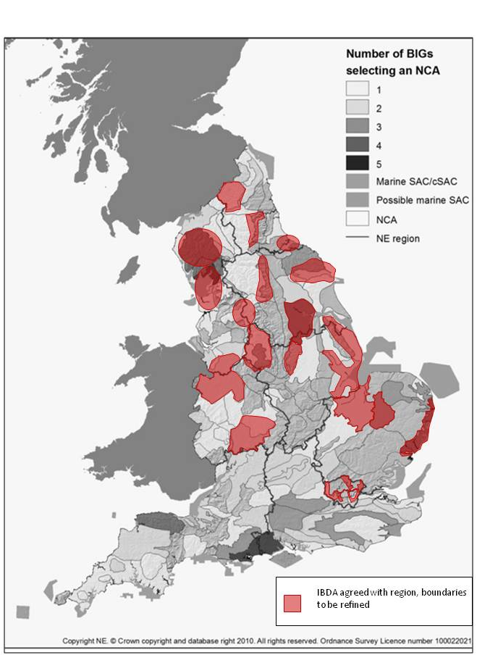
Figure 1: Map of potential IBDAs (7th April 2010)

- Next Steps

  - Table 2 shows the timetable for the next six months for those Regions where the required number of IBDAs were identified at the workshops. Discussions are continuing with the Regional Biodiversity Partnerships for the south-west and the south-east with the expectation that they will be able to put forward a suite of draft IBDAs by the end of May, thus meeting the requirements of the proposed timetable. This would allow a single round of consultations with BIGs and Taxon Groups in July. Should this not happen, a later round of consultation would need to be added to the timetable.

 | April | May | June | July | August
- EBG endorse approach and agree draft suite of sites
- Regions set draft detailed boundaries and undertake audit to identify proportion of BAP targets in each IBDA
- BIGs & Taxon groups to identify interests and opportunities in IBDAs
- Regional audit of existing projects and partnerships within IBDAs
- Set final boundaries and targets
- Promotion of IBDAs
- Report to EBG

  - Process details for stages:
- Following endorsement of this approach by EBG, Regions will draft more detailed boundaries for each proposed IBDA, taking account of local knowledge of priority habitats and species, existing projects, BAP commitments etc. Once this draft boundary has been set, regions will then be able to identify the contribution of each IBDA to regional BAP targets. This work will be coordinated by the RBC.
- In late June/early July, a package of information for each proposed IBDA will be presented to BIGs and Taxon Groups. This will consist of the draft boundary, existing information about priority habitats and species in the area and the expected contribution of each area to BAP targets. BIGs and Taxon Groups will use this information to identify opportunities for partnership working in a suite of IBDAs to deliver habitat enhancement and creation and to meet the needs of associated priority species. There is also an opportunity to propose changes to the draft boundaries to maximise the value of the IBDA and to ensure that the maximum synergy between habitats and species interests is achieved.
- Before and during this consultation process, the Regional Biodiversity Partnerships will also carry out an audit of existing biodiversity delivery work in the proposed IBDA. This should help to identify projects and partnerships that can be included in future integrated delivery work.
- Regional Partnerships will then use the feedback from the BIGs and Taxon Groups to finalise the boundaries of each IBDA. The audit should also allow the identification of new projects and partnerships that can be developed as contributions to the integrated delivery plan for the area.
- A report on the operation of this process and the outputs from it will be presented to the EBG in Autumn 2010.

- Request to EBG

The England Biodiversity Group is requested to:
- Note the significant progress made towards selecting a suite of IBDAs in the nine regional workshops
- Endorse the suite of draft IBDAs identified in Table 1 and the process for their continued development, recognising their important contribution to the Securing Biodiversity framework.
- Agree a formal mechanism for resolving which of the candidate IBDAs are taken forward and ensuring that their development proceeds as proposed . We recommend that this function is delegated to the Securing Biodiversity Management Group.
- Communicate and recommend the value of this integrated landscape-scale approach to member organisations and the wider biodiversity partnership. Encourage member organisations to actively seek opportunities to deliver more for biodiversity in these areas.
- Advise on the timing and method of promoting these areas, in particular in the context of the ‘Making Space for Nature’ review of England’s wildlife sites and ecological network chaired by Prof. Sir John Lawton.
- Advise on what emphasis should be placed on IBDAs and their contribution to delivering BAP targets, so as to achieve a balanced programme addressing all strands of the Securing Biodiversity framework.

David Appleton
Helen Moggridge
Tilly Tillbrook

Natural England

7th April 2010
Version 1

